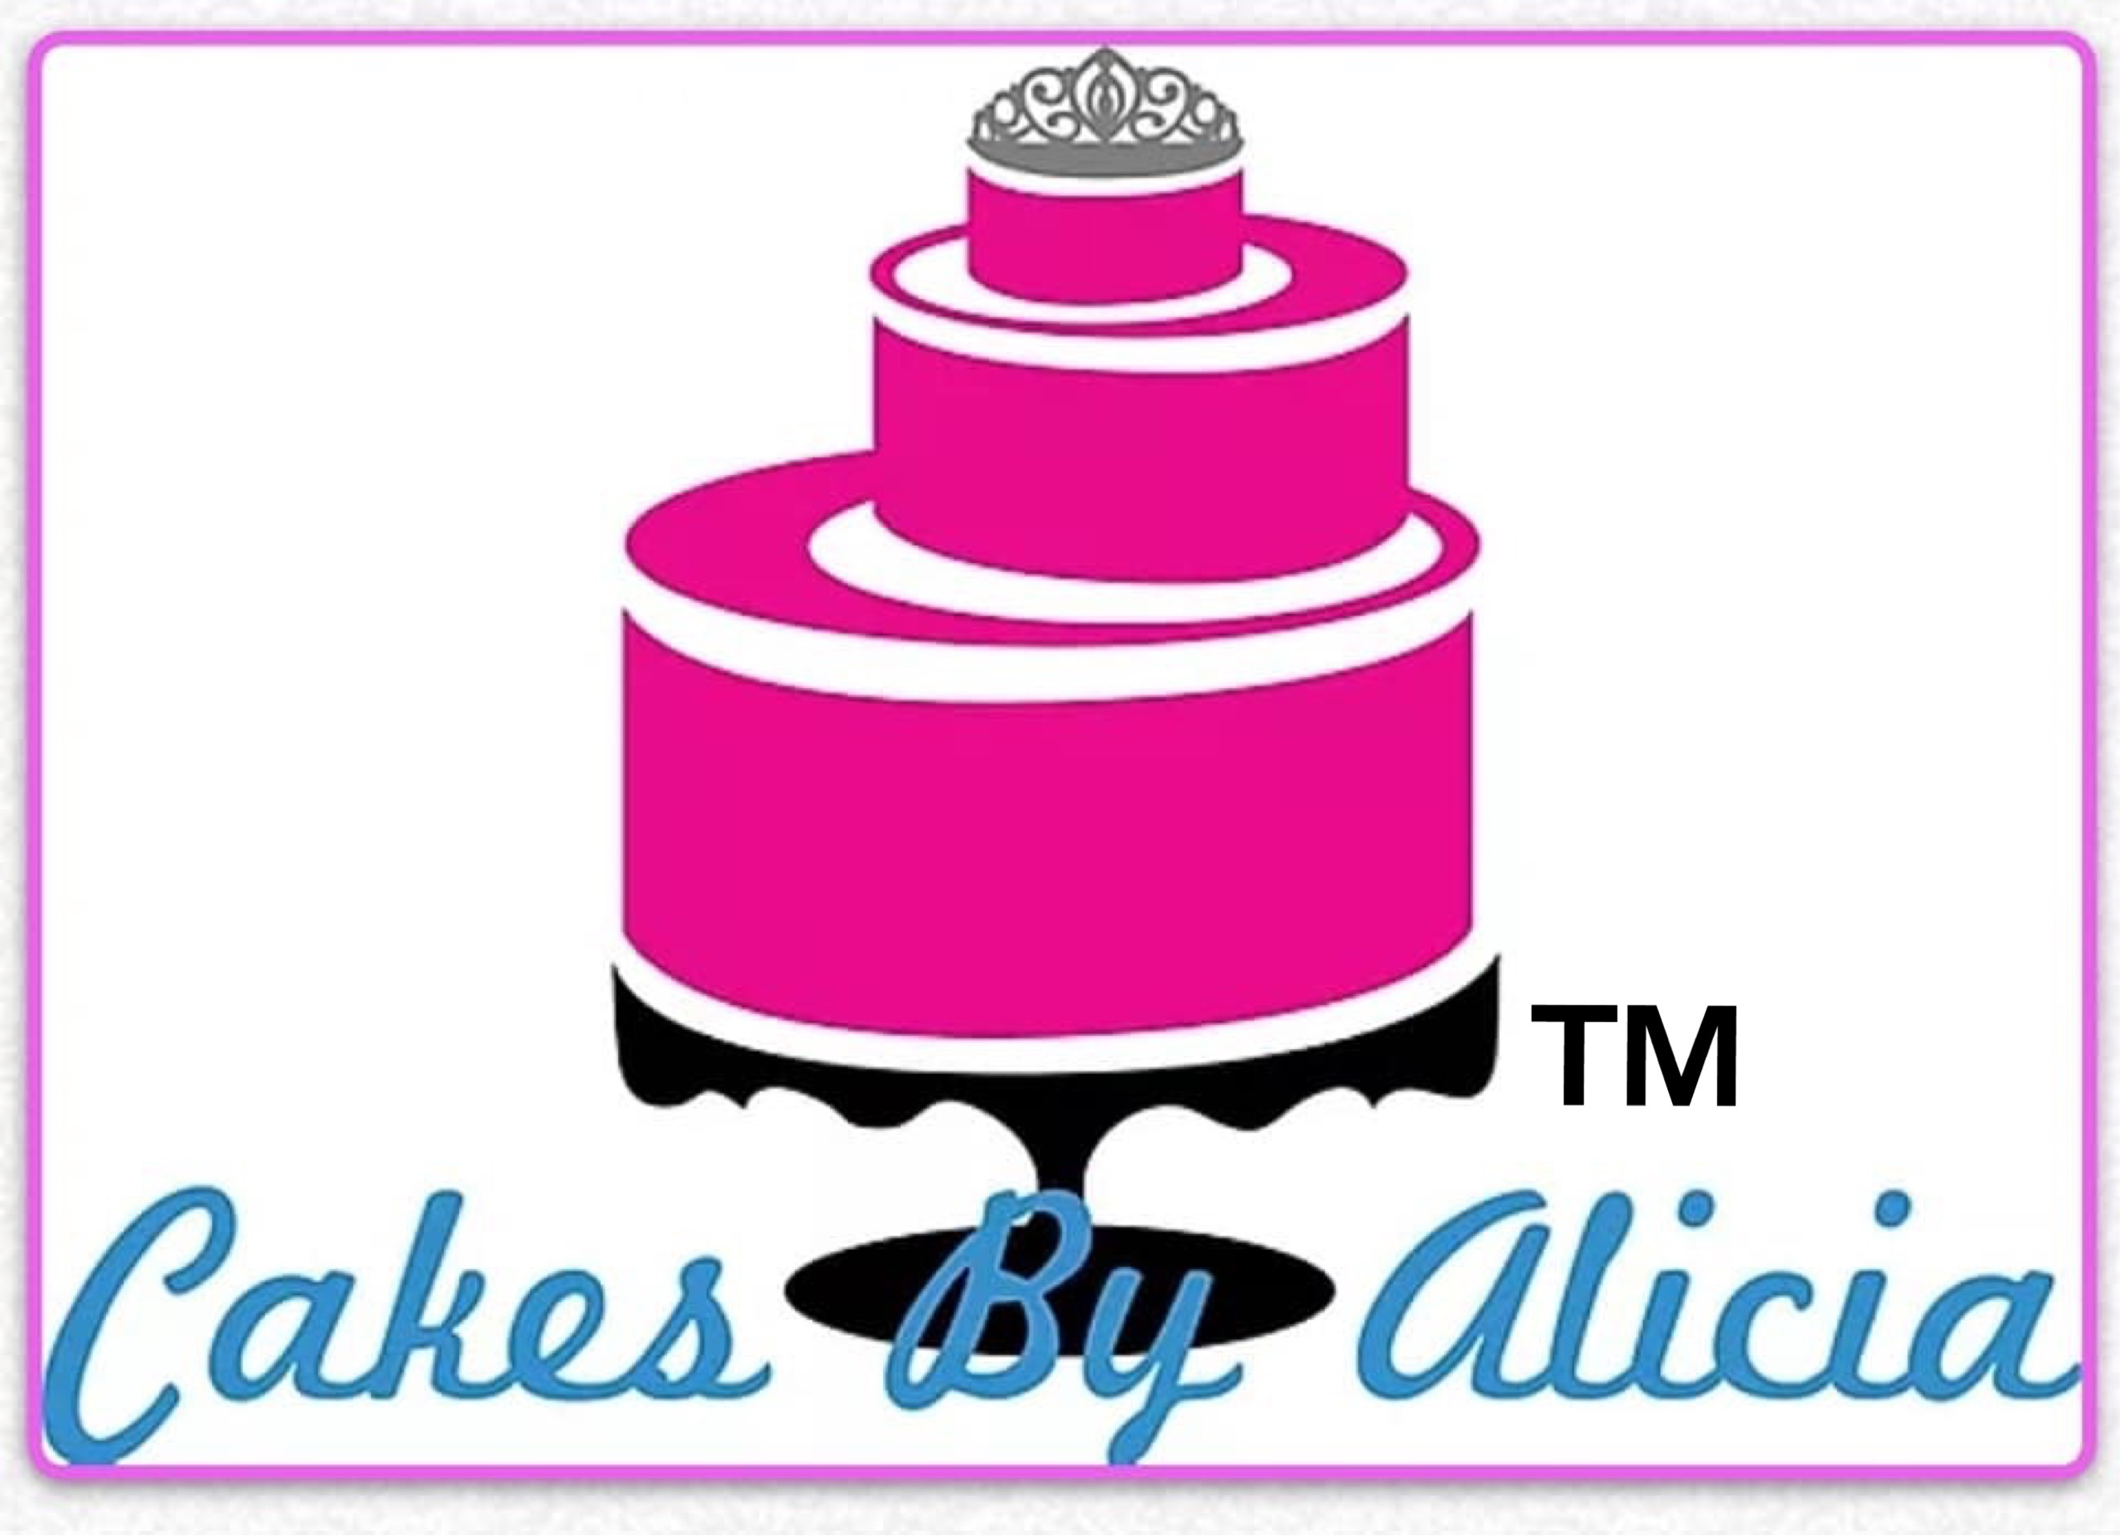

Cakes by Alicia price list.

**SLICES: $65 tray of 12 large slices or 24 small slices**

Double Choc cheesecake Slice

Choc caramel brownie

Iced coffee Slice

Caramel slice

Cookie dough Slice

**Slices: $55 Tray of 12 large slices or 24 small slices**

Jelly Slice

Rocky road

Birthday cake blondie

Chocolate Brownie

**Mixed Slice tray:**  24 small pieces $120 (Mixture of 24 slice pieces)

**Chocolate covered strawberries: $2.00ea (**min of 10**)**

**Cake pops – Starting at - $4.00ea** (min of 8)

**Cakesicles LRG – starting at - $6.50**

**SML – starting at - $4.50**

**Fondant cookies – Start at $4.50ea** (min of 8)

**Specialty Cupcakes – start at $4.50ea** (min of 6 of 1 flavour)

Mars Bar

Cookies & Cream

Top deck

Red velvet

Nutella

Funfetty

Choc mint

Strawberry milkshake

**Cheesecakes: $70 - 8 inch round**

Caramilk

Rolo

Oreo

Mixed Berry

Nutella Ferrero

Double Choc

Mars Bar

Choc Caramel

**Dessert cups: $6.50 ea – 120ml $8.00ea - $170ml**  (minimum of 6 of the same flavor per order)

Cheesecakes as above

Banoffee pie cups

Chocolate mousse cups ($5ea)

Choc Mud cheesecake cups

(layers of chocolate mud cake and cheesecake with chocolate ganache top)

**Specialty Cakes:**

(7 inch round – 12-16 café servings / 9 inch round 12-24 café servings)

Basic Mud cakes with Ganache or buttercream icing. . . . . . . . . . . . . . . . . . . . . $95.00-6inch round / $140.00- 7inch round

(Chocolate, Caramel, White chocolate, Strawberry, Banana, Vanilla)

Red velvet with cream cheese icing . . . . . . . . . . . . . . . . . . . . . . . . . . . . . . . . . . $85.00-6inch round / $110.00-7inch round

Snickers. . . . . . . . . . . . . . . . . . . . . . . . . . . . . . . . . . . . . . . . . . . . . . . . . . . . . . . . . $120.00 6inch round / $140.00- 7inch round

(Chocolate mud cake with layers of cake, salted caramel and

peanut butter cream cheese filling all covered in chocolate ganache)

Black Forrest. . . . . . . . . . . . . . . . . . . . . . . . . . . . . . . . . . . . . . . . . . . . . . . . . . . . .$95.00 – 6inch round / $120.00- 7inch round

(Chocolate mud cake with layers of fresh cream and a cherry sauce)

**Mud cake Flavors:**

(Sizes and prices vary)

Chocolate Mud

Caramel Mud

Strawberry Mud

White Chocolate Mud

Vanilla Mud

**Cake Filling Options:**

(between the cake layers)

Vanilla buttercream

Strawberry buttercream

Chocolate buttercream

Nutella buttercream

Caramel buttercream

Lemon curd

Passionfruit curd

Salted caramel

Cakes By Alicia

0419631381

cakesbyalicia@outlook.com